Analysis of Factors Driving Healthcare Costs

Brian Salant

Dylan Howe

Luke Morrissey

Connor Cute

July, 21st 2018

When we began the project the base question that we wanted to have answered was regarding food deserts and health care. This question then drove us to form another, broader thesis question about the driving factors behind healthcare costs. In order to break down this broad question into smaller challenges and questions, we had to examine a lot of different data.

Our first question revolved around if there are any socioeconomic factors that correlate with higher admittance rates into drug rehab facilities across the US, from which we hypothesized that if there were more people in rehab healthcare cost would increase.

Our second question revolved around if there are hospital deserts and if so, what socioeconomic factors might play a role in their locations, from which we assumed that deserts existed in greater extent in rural areas.

Finally, our third question wraps everything up and asks how the cost of a healthcare visit varies across the country and is healthcare more expensive in certain areas, from which we assume that high income communities have more expensive healthcare than low income communities

Answering these questions involved statistics on socioeconomic status, hospital locations, hospital costs, rich versus poor, rural versus urban. Due to the large amount of data, it was sometimes hard to find trends. While this may be somewhat frustrating it didn't leave us with a lack of findings and we can conclusively say that where there are trends they do support and undermine our hypotheses depending on how one looks at them.

**First Question:**

The major finds and accomplishments of this question is determining that our hypothesis was incorrect and that it appears the many of the data points we examined have a minimal influence on healthcare cost in relation to rehab. This is backed up by most of the data falling into the ‘norm’ for what is expected.

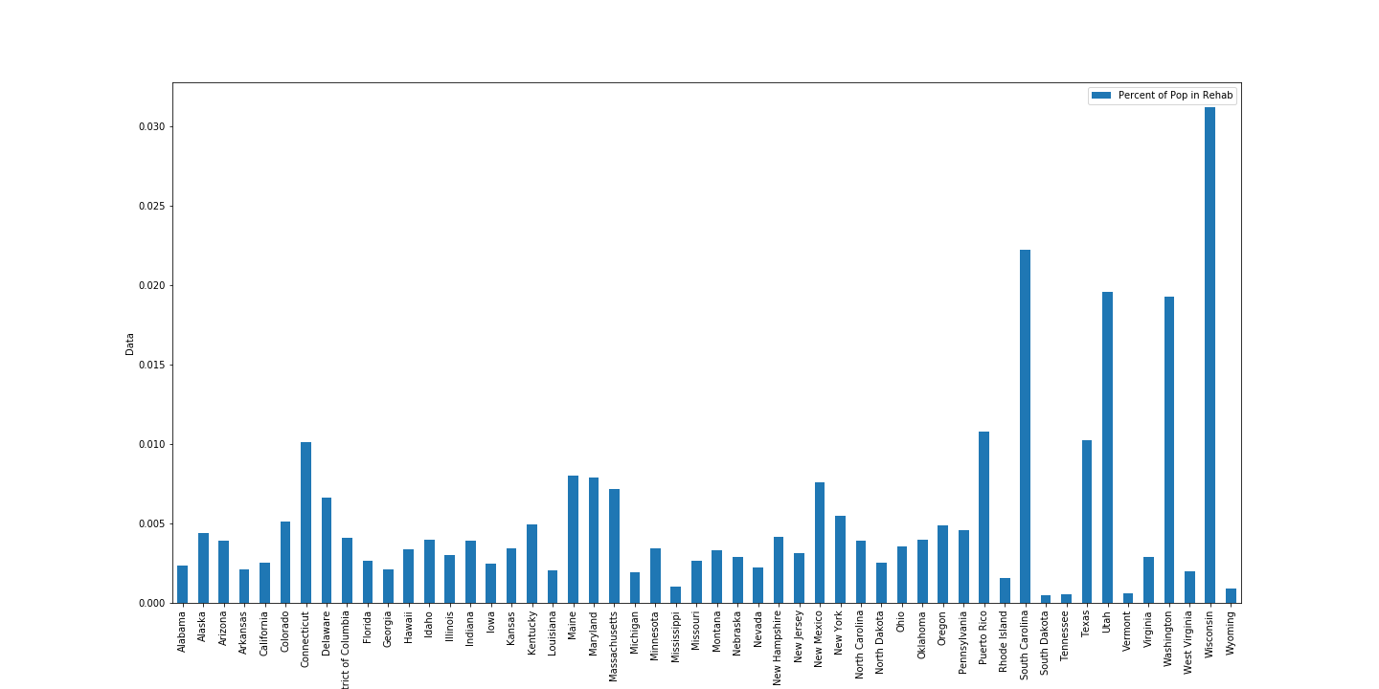

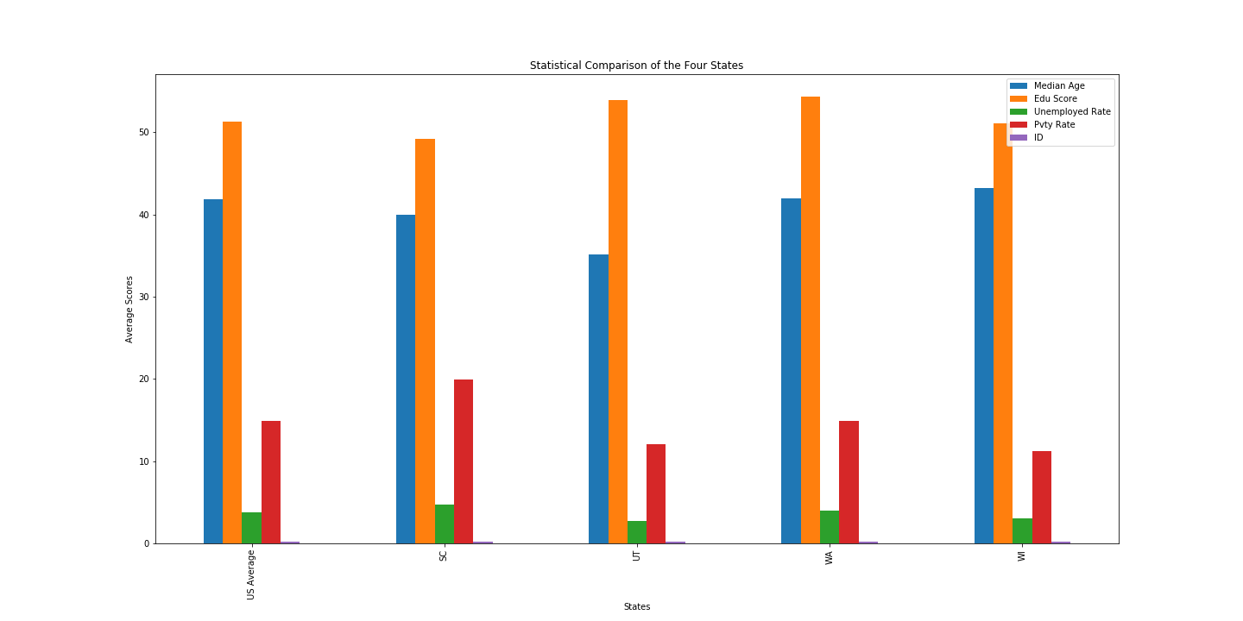

**Second Question:**

The major finds and accomplishments of this question lie within fact that as median household income increases the rural neighborhoods tend to be less farther away from a hospital. This point backs up the hypothesis and other data points that indicate that hospital deserts are created by lower wealth and density.

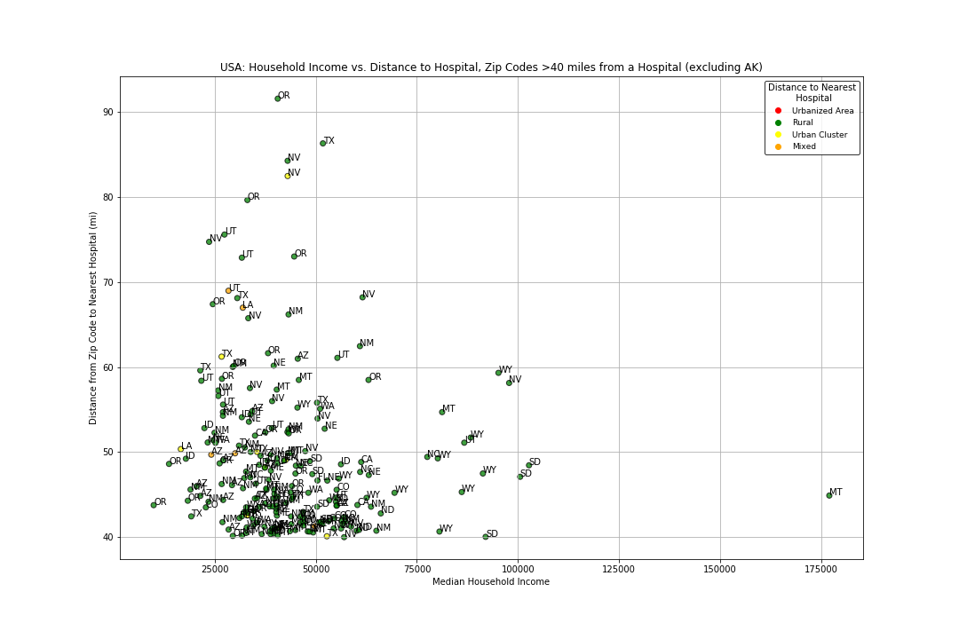 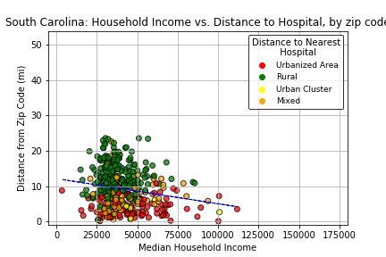

**Third Question:**

The results for the third question are somewhat similar, using the median household income to prove a by a large margin that there is a correlation between income and healthcare cost. This can also be expanded upon due to the nature that urban areas are usually more affluent than rural areas, going as far as o say that urban areas are more expensive in general.

